Modelling the Economic Impact of a Citizen’s Basic Income in Scotland – a guide to the report released today

The [report](https://www.sbs.strath.ac.uk/download/Fraser/202004/Modelling-Economic-Impact.pdf), co-authored by researchers from the Fraser of Allander Institute, Manchester Metropolitan University and IPPR Scotland, looks at the costs and benefits of implementing a basic income in Scotland and the channels through which it may impact upon the economy.

The modelling we were asked to carry out is fiscally neutral – that is, it looks at the reality of how to pay for a basic income, as well as the impact of paying out the basic income.

We were asked to model 2 versions: a lower level basic income that replicates the standard allowances already in place in much of the social security system and a second, higher level, CBI that used the Joseph Rowntree Foundation's Minimum Income Standard as a guide to the level of payments.

The cost of the lower basic income is estimated to be £27 billion. The cost of the higher-level basic income is estimated to be £58 billion.

Although savings could not be realised within the current devolution framework, around £20 billion could theoretically be offset via replacing existing benefits (including the state pension) and eliminating the personal allowance. This leaves around a £7 billion funding requirement for the lower level CBI and around £40 billion for the high level.

Our model looks at the impact of using income tax to pay for the remaining cost, and then considers the impact on the economy of both the basic income and changes in tax. To fund the lower level basic income, an increase in 8 points on each Scottish income tax band would be required, with people paying income tax on even the first pound of income because of the abolition of the personal allowance. Changes to fund the higher-level CBI would be significantly greater.

Other tax combinations are possible, although using income tax provides a helpful benchmark given its scale, its progressive properties and its devolved nature. Alternative taxes or spending cuts would also have significant implications for the economy given the scale of the funding requirement.

We show that what happens to the economy depends upon how people respond to both the introduction of the basic income and the increase in tax. 55% of people would be net gainers from the lower level basic income we modelled and 45% of people would have less take-home income (i.e. after tax and the basic income is paid).

If people who lose income take some action to restore their living standards by demanding more pay or changing how much they work (i.e. by changing their hours or moving elsewhere), then we might expect negative economic impacts. If people instead are content to see their own income reduced due to the existence of a basic income that benefits others, then we might expect more positive impacts.

Other impacts, such as changes to productivity (good and bad) may also occur. At present, there is a lack of evidence – both here in Scotland and internationally – to say conclusively what the final economic impact will be.

**Q&A**

**Who carried out this work?**

This work was carried out by a team of researchers from the Fraser of Allander Institute at the University of Strathclyde, Manchester Metropolitan University and the Institute for Public Policy Research (IPPR) Scotland

**What were you asked to model?**

We were asked to look at the distributional and fiscal impacts of different revenue neutral CBI schemes and to use a macroeconomic model of the Scottish economy to highlight the channels through which such changes in the tax & benefit system could impact upon economic outcomes over the long-run.

We were asked to model a basic income that replicates the standard allowances already in place in much of the social security system and applied these as a Citizens Basic Income (CBI). A second, higher level CBI was also modelled, and the results from this are available in the full report.

**Table 1: Citizens Basic Income weekly values in 2019/20**

|  |  |
| --- | --- |
| Age band | Low-level CBI |
| 0 to 15 | £84.54 |
| 16 to 19 | £84.54 |
| 20 to 24 | £57.90 |
| 25 to below State Pension Age | £73.10 |
| State Pension Age or over | £163.00 |

**How much would the schemes you modelled cost?**

The gross cost in 2023/24 of paying a low-level CBI (replicating standard allowance)[1] in Scotland would be just under £27 billion per annum. Abolishing the standard elements of means-tested benefits, Carers Allowance and Child Benefit would save £4 billion[2]. Reducing the state pension by the amount of each pensioner’s CBI would save just over £6 billion, whilst abolishing the personal allowance for Income Tax would save £9 billion.

This would leave a little over £7 billion to be raised through other tax increases of some kind.

If this funding requirement was paid for by increases to Scottish income tax, this would require an increase of 8 percentage points on each tax band, so the starting rate of tax would increase to 27%. It is also important to note that this would be levied on the first pound of income due to the abolition of the personal allowance.

**Table 2: Costs of a low-level and high-level basic income**

|  |  |  |
| --- | --- | --- |
| **Option** | **1** | **2** |
|  | **Low-level CBI** | **High-level CBI** |
| **Gross cost** | **-£26.7 bn** | **-£57.8 bn** |
| Savings from benefit reductions | £4.0 bn | £4.0 bn |
| Savings from state pension reduction | £6.3 bn | £6.6bn |
| Savings from PA abolition | £9.1 bn | £9.0 bn |
| Savings from tax rate rises | £7.2 bn | £38.3 bn |
| **Net cost** | **-£0.2 bn** | **£0.1 bn** |
| Income tax rate rises needed to achieve fiscal neutrality | +8 points on every band | +49 pts on band 3 +44 pts on band 4 +39 pts on 1,2,5 |
| New Scottish income tax schedule[3] | 27:28:29:49:54 | 58:59:70:85:85 |

**Why did you assume that Income Tax would be used to pay for it?**

Other tax combinations are possible. However, income tax is the principal devolved tax of sufficient scale at the current time– for example, it currently raises around £13 billion compared to around £2½ billion from council tax. It is also progressive, in contrast to other taxes such as VAT[4].

All taxes, levied at the level required, would have implications for household budgets and hence behaviour. As a result, whilst specific changes may vary, the overall size of the economy would be affected through similar channels to those that we have modelled with income tax.

The central issue is that funding of £7.2 billion (for the low-level CBI) has to be financed. In principle, this could happen through some combination of raising taxes or cutting other expenditure. However, the fundamental trade-offs apparent in our analysis – between the benefits of a CBI and the costs associated with its financing - would not be eliminated by other means of financing the shortfall.

**What was the impact on poverty of the low-level CBI?**

With the low-level CBI, we modelled that this would reduce the number of people in poverty by 280,000 (5.4 percentage points) and the number of children in poverty by 90,000 (9 percentage points).

The cost per person lifted out of poverty for the low-level CBI were £139,000 per person, and for children £293,000 per child.

The reductions in poverty for the more generous higher-level CBI were larger. Full results are in the report.

**Did you look at any alternative policies?**

We were also asked to model a comparison policy aimed at reducing child poverty. Our chosen policy increased the main child element of Universal Credit by £40 per week[5] and abolished the benefit cap and the two-child limit for Universal Credit.

This policy would cost £1 billion per annum in 2023/24 and would require an increase of 6 percentage points on only the top two income tax bands. It would reduce overall poverty by 170,000 and child poverty by 100,000 (more than the lower level CBI).

The cost per person lifted out of poverty would be £15,000 and per child the cost would be £10,000 (compared to £293,000 per child for the lower level CBI).

**Who would be impacted by CBI?**

In general, people on lower incomes gain from a basic income and those on higher incomes lose due to higher tax rates.

However, it is important to note that this pattern is not uniform. For example, higher-earning couples with only one earner and three children would gain five citizen’s incomes and lose only one income tax personal allowance and no Universal Credit so might actually be net gainers from the policy. Similarly, a low-earning couple with two earners and one child on Universal Credit might lose out due to losing their Universal Credit in return for the CBI but paying more tax.

It is also notable that almost nobody is unaffected by the introduction of the CBI: everyone gains or loses, some by significant amounts. 1.7 million people will see their family income rise by £2,500 a year and nearly one million will see a loss of that amount. In contrast, nearly two-thirds of people would see no change in family income under the Universal Credit child elements policy.

**Figure 1: Change in annual family income**

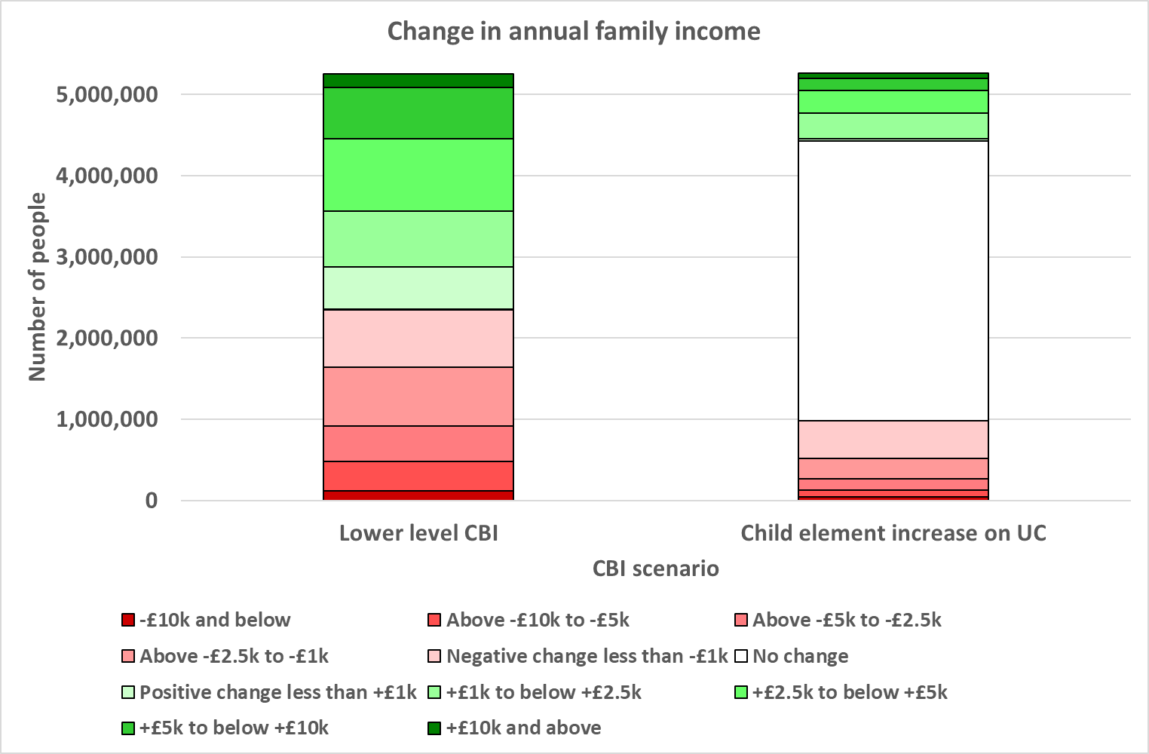

**What are the possible longer-term macroeconomic effects of a basic income?**

Because of the transformational nature of the change that a CBI involves, there is no precedent in terms of how society would respond. Existing studies have tended to be limited to local pilots (rather than at a national scale) or focus upon one aspect of a CBI, e.g. the introduction of a universal benefit but they do not test how people respond to the taxation required to fund the policy. Of course, how people respond to the funding mechanism is equally as important as their response to the CBI itself.

We therefore explored a number of scenarios.

* If people who saw their income fall were happy to see this loss of take-home earnings transferred into paying the basic income for others in society, then the macroeconomic impact could be limited.
* If people attempted to recoup some or all of their earnings ‘lost’ in tax[6], for example, by moving out-with Scotland or trying to bid up their wages to compensate or cutting back on their hours worked, there would be negative macroeconomic impacts. This impact may be large in some scenarios.

These are scenarios, and not subjective judgements on whether or not an outcome is ‘good’ or ‘bad’. It is simply to highlight the net impact upon economic activity. Some will argue that trading-off some activity for other outcomes, such as greater equality, is worth it. It all depends how people faced with these trade-offs behave.

As we emphasise in our report, a social contract that implied a willingness by many to accept a lower real disposable income in return for the greater equity created by a CBI, could minimise any adverse macroeconomic impacts. Our report makes no subjective judgment on whether or not such a social contract is achievable, either within Scotland or even if it could be, whether or not Scotland could do so on its own without considering what other countries might do.

In all scenarios, we would see some increase in consumption spend because of the redistribution of income to lower income households who are more likely to spend additional income rather than save.

**What does your model say about the possible impact on the size of the economy?**

Our modelling of the low-level CBI uses a scenario that assumes that people take into consideration of the value of the CBI they receive and then seek to increase their wages to keep their own income the same as it was pre-CBI.

The long run-impact, if we assume a strong migration response, would be a reduction in the size of the economy by around 15% according to our model due to the impact of the increase in wage costs. It is important to reiterate that impacts could be higher or lower than this this – significantly lower with a muted migration response - and is wholly dependent on how people respond to the new income and to the new tax rates

It should be noted that what we are not saying that the economy will immediately ‘shrink’ by that amount – instead this is how much smaller the economy would ultimately be relative to a baseline in the future. Of course, however, relative growth matters too.

**Would we see improvements in the economy if people have more choices and wellbeing is improved?**

There are other – more indirect – avenues through which a CBI may impact upon the economy.

Evidence from a range of CBI-type studies, a review of which is included as an annex to our report, looks at interventions around the world. This review found some qualitative evidence of beneficial effects that could impact the economy, for example, through reduced precarity and improved mental health, and the possibility of freeing people to improve their human capital or engage in entrepreneurial activity. This could lead to long-term savings too for public sector budgets.

Quite a lot of the case study evidence, however, relates to CBI-type interventions that were either externally funded (e.g. via a sovereign wealth fund) or that are small scale and effectively imply that zero costs are borne by CBI recipients. So, applicability to the Scottish case is not immediately obvious.

Nonetheless, the potentially beneficial effects on individuals’ well-being could potentially prove important to the economy over the longer-term. Unfortunately, however, there is currently little or no indication of the likely scale of such effects (and, in general, there is even ambiguity about the direction of some effects).

If there was a significant boost to productivity due to improvements in health and wellbeing, then there would be offsetting positive macroeconomic impacts. Those productivity impacts would however likely need to be large to make an impact on the scenario we set out above.

There will be other factors at play too. Some people may choose to work less as a result of the basic income. Some of these people may take some time out to volunteer. Some may permanently reduce their paid labour, but this in itself may have positive benefits for society.

Exactly how a basic income would unfold cannot be predicted. Much more evidence to understand the behavioural implications is required to facilitate an evidenced based policy decision on a basic income.

The full report can be found [here](https://www.sbs.strath.ac.uk/download/Fraser/202004/Modelling-Economic-Impact.pdf).

1. All amounts are increased in line with inflation to 2023/24
2. Whilst standard elements would be abolished, additional support within the means-tested benefit system for disabled people and for housing and childcare costs would remain
3. Scottish Income Tax bands: Band 1: £1 to £2,049; Band 2: £2050 to £12,444; Band 3: £12,445 to £30,930; Band 4: £30,931 to £150,000: Band 5: £150,001 plus
4. As we discuss below, what is important is how people respond to both the introduction of a CBI and significant increase in taxation. In that regard, the ‘type’ of tax is very much a secondary issue. What matters is the relative scale of change which will impact upon people’s behaviours no matter the specific form of tax used.
5. The first child element of Universal Credit was increased to be the same as the new, higher, second and subsequent child element.
6. In effect, for every £1 earned from working, a larger share of it would be transferred to others in society as opposed to going to the employee directly. At the margin, they would be content with accepting a £1 reduction their personal disposable income provided it was spent on the CBI